Dyslexia and ESOL families by Olga Lapteva
Resources:

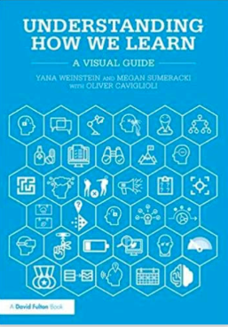

Hammond, Z., & Jackson, Y. (2015). Culturally responsive teaching and the brain: Promoting authentic engagement and rigor among culturally and linguistically diverse students. Thousand Oaks, CA: Corwin, a SAGE Company.

Brown, P. C., Roediger, H. L., & McDaniel, M. A. (2014). Make it stick: The science of successful learning. Cambridge, MA: The Belknap Press of Harvard University Press.

Weinstein, Y., Sumeracki, M., & Caviglioli, O. (2019). Understanding how we learn: A visual guide. Abingdon, Oxon: Routledge.

http://www.learningscientists.org/downloadable-materials

